**PROJECT DEVELOPMENT PHASE**

**SPRINT-2 CONNECTION (Interface Sensor)**

|  |  |
| --- | --- |
| Date | 05 November 2022 |
| Team ID | PNT2022TMID12310 |
| Project Name | IoT Based Smart Crop Protection System for Agriculture |
| Maximum Marks | 8 Marks |

Device Details:

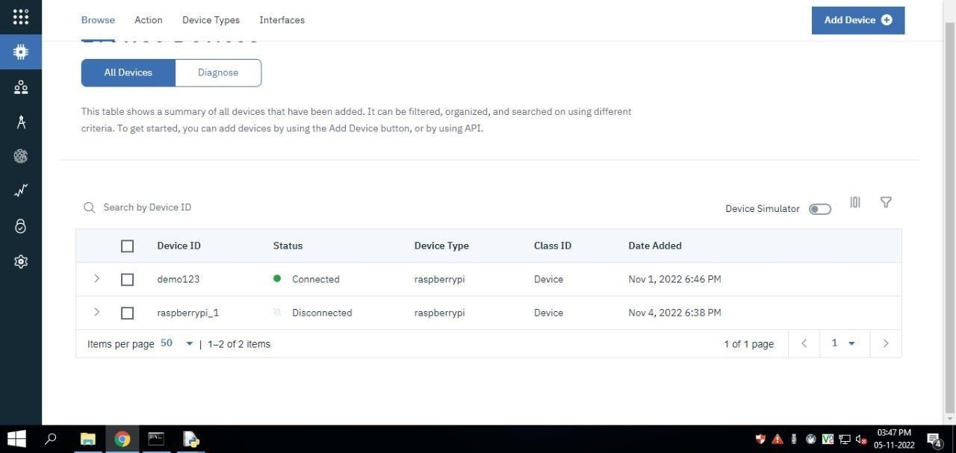

Recent Events:

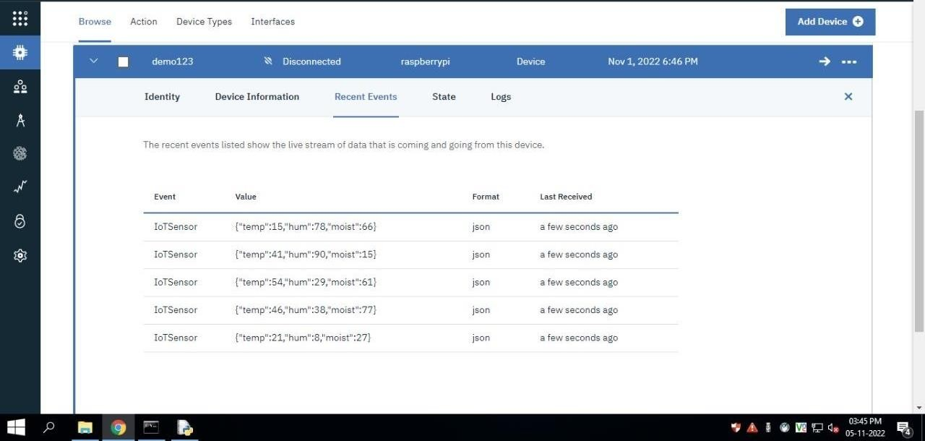

Node-Red Connection and Dashboard Design:

